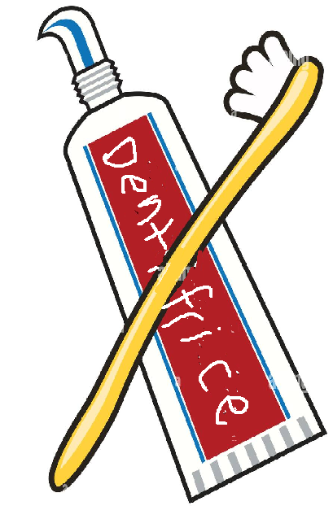
Nom : _____________________________________________________________ Heure: ___
Français 2, Unité 3C
Les accessoires de toilette / Vouloir / Pouvoir : RallyCoach

Take turns with your partner, one person explaining the answer and the other person writing it down. This is 50% a speaking activity and 50% a writing activity, so make sure you’re doing both !

- I want the comb.

- We want the washcloths.

- I saw the makeup.

- I have eaten the soap!

- She has come to the house.

- I can study?

- I want to eat!

- We can eat.

- He wants to go to the mall.

- We can go to the mall!

