
S/V Retriever

Voyage Passport

Name : ____________________
Watch Group : ______________

Welcome, Sailors !

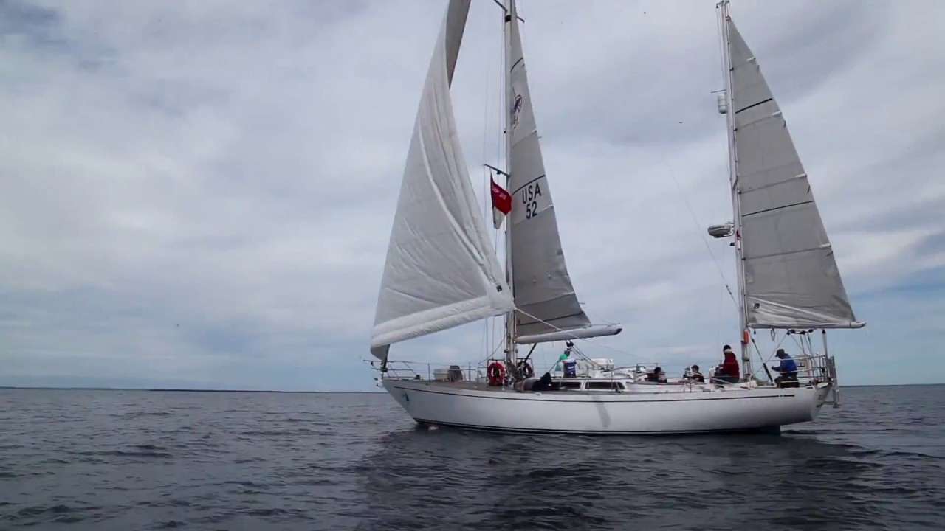

We’re excited to have you as part of the crew ! In the following pages we’ll show you the things we’ll do and the tasks you will learn. There is also a section that shows you some of the ports we may visit on this trip. Welcome aboard !

A Message from The Captain

The captains and crew of the Retriever are really looking forward to sailing with you. During your time on the water, you will actually gain the knowledge and skills to sail a 52ft ketch. As part of the crew, scouts learn to respect others, as well as to work as an efficient team to meet the many challenges of sailing in our Great Lakes. The Great Lakes Sailing Adventure Program will provide scouts with experience and memories that last a lifetime.

There are many things that scout troops can do in the weeks before arriving at Mackinaw City and the Retriever. We can’t stress enough that leaders and scouts read and carefully follow all the requirements in the Leader's Guide. Copies of the Scouts Training Manual will be provided, and scouts can always get online to access these program materials. We encourage scouts to watch YouTube videos on the fundamental skills needed to sail a boat the size of the Retriever. YouTube Videos are great ways to learn the fundamentals of using winches, raising sails, tacking, and steering a boat to maintain a plotted course. The captain assigned to your sailing adventure will reach out to you many weeks before your sailing adventure begins. We encourage all the members of your troop to use FaceTime, Zoom, and/or other social media to connect with your captain so all of your questions and concerns can be answered. Also, we encourage you to go online and “visit” the ports we might go to during your trip. Some examples are on the following page.

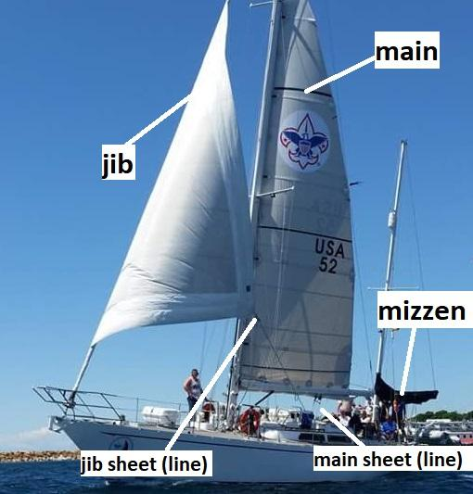
Lake Huron ports we might visit
Bois Blanc Island | 45 46’ 00” N, 084 26’ 10” W
Cedarville / Les Cheneaux Islands | 45 59’ 53” N, 084 21’ 47” W
Cheboygan | 45 38’ 49” N, 084 28’ 28” W
DeTour | 46 00’ 30” N, 084 00’ 09” W
Hessel | 46 00’ 15” N, 084 25’ 33” W
Mackinac Island | 45 51’ 52” N, 084 37’ 32” W
Mackinaw City | 45 47’ 02” N, 084 43’ 40” W

Lake Michigan ports we might visit
Beaver Island | 45 39’ 53” N, 085 33’ 26” W
Boyne City | 45 13’ 00” N, 085 00’ 50” W
Charlevoix | 45 19’ 05” N, 085 15’ 30” W
Petoskey | 45 22’ 24” N, 084 57’ 19” W
St. Helena Island | 45 51’ 41” N, 084 52’ 22” W
Traverse City | 44 45’ 47” N, 085 37’ 14” W

Trainee Arrival -- Scout Etiquette
Topic | Explained to trainees ?
Your troop represents the
Boy Scouts of America
We are guests of the communities we visit
and we want to be invited back!
Orders from the captain and
mate are mandatory
Always and Never
Always be a good shipmate
Never bring drugs or alcohol aboard the vessel
Always follow orders when underway
Always ask and never guess
Always report a problem with equipment or facilities
Always keep your bunk area clean and orderly
Always respect other people’s property : be the person your mother would be proud of !
Never touch anything in the navigation
station without permission
Always wear your PFD above deck but never activate it unless it’s an emergency

Trainee Arrival - An Orientation to the Boat
Topic | Explained and Demonstrated?
Boarding safety
Going from the boat to the dock
Safe way to go up and down the ladder
Marine head training
Conservation of ship resources
Everything has a place on a boat (keep it neat !)
Moving around the deck (always holding on)
Watch out for the boom !
Location / use of PFDs
Survival suits

Emergency procedures
Topic | Explained and demonstrated to trainees ?
What to do if you fall overboard
Man overboard drill
Fire drill / trainee
role in fire emergency
(* do not attempt to activate the emergency sprinkler system)
Location of fire extinguishers
Severe weather - what to do
Location of life sling and PFDs
Abandon ship - what to do

Before getting underway
Topic | Explained and demonstrated to trainees ? | Accomplished ?
How to tie a cleat
How to coil and throw a dockline
Dockline numbers
Docking/undocking language | - Hold □  - Make fast □  - Take up slack □  - Ease □  - Haul □
Leaving / arriving at the dock (what will happen)
Follow the commands of the harbor dockhands
Repeating commands you hear

On-deck skills (all hands explanation)
Topic | Explained and demonstrated to trainees ? | Accomplished ?
Raising the mainsail
Lowering the mainsail
Flaking the mainsail
Unfurling the jib
Furling the jib
How to use a winch

Points of Sail

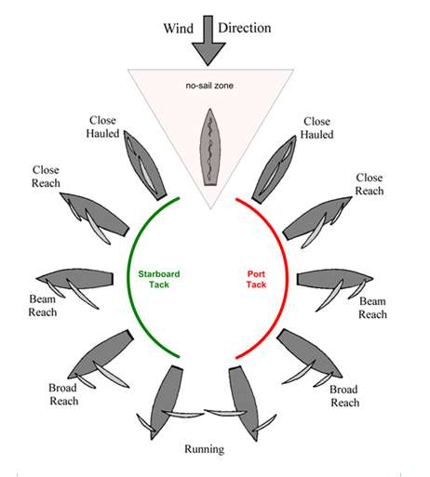

Aids to Navigation

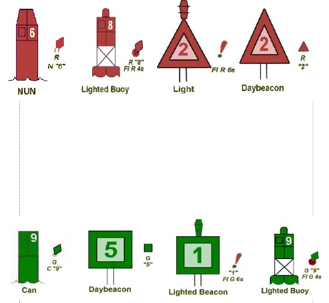

Rules of the Road - Simplified
- Post a lookout - Sight and hearing
- Maintain safe speed - visibility, vessel traffic, ability to maneuver and weather conditions
- Avoid a collision

Overtaking Situation
Portside | Starboard side
- 2 short blasts for intention to overtake  - 2 short blasts for agreement | - 1 short blast for intention to overtake  - 1 short blast for agreement
Head-on Situation
Port-to-port passing | Starboard-to-starboard passing
- 1 short blast for intention to pass  - 1 short blast for agreement | - 2 short blasts for intention to pass  - 2 short blasts for agreement
Crossing Situations
- Give-way vessel - required to yield - 1 short blast for intention to cross astern
- stand-on vessel - maintain its course and speed - 1 short blast for agreement

Trainee Individual Checklist
Vocabulary
Term | Self-Assessment (Trainee) | Captain / Mate Initials - trainee explains term back to captain or mate
Ease the line
Make fast the line
Main sail
Jib
Mizzen
Port
Starboard
Bow
Stern
Halyard
Sheet
Tack
Jibe
Forward
Aft
Listing
Heeling
Underway
Helm
Boom
Cleat
Mast
Head up
Fall off
Close-hauled
Close reach
Beam reach
Broad reach
Dead run

Trainee Individual Checklist
Navigation and Sailing Skills
Topic | Self-Assessment (Trainee) | Captain / Mate Initials
Making a logbook entry with GPS position
Recognizing landmarks on the chart and in real life
Using depth to approximate position
Plotting position on a chart
Plotting course on chart
Determine arrival time based on current position, course and speed
Explain function of buoys
Handle sails through a tack or jibe
Steer through a tack or jibe
Steer a course

Trainee Individual Checklist
Knots and hitches
Name | Self-Assessment (Trainee) | Captain / Mate Initials
Round turn and two half-hitches
(*to tie on fenders)
Clove hitch
Slippery half-hitch
Figure-eight knot
Reef knot
Coiling and hanging a line

Journal Day 1
________________________________________________________________________________________________________________________________________________________________________________________________________________________________________________________________________________________________________________________________________________________________________________________________________________________________________________________________________________________________________________________________________________________________________________________________________________________________________________________________________
Journal Day 2
________________________________________________________________________________________________________________________________________________________________________________________________________________________________________________________________________________________________________________________________________________________________________________________________________________________________________________________________________________________________________________________________________________________________________________________________________________________________________________________________________
Journal Day 3
________________________________________________________________________________________________________________________________________________________________________________________________________________________________________________________________________________________________________________________________________________________________________________________________________________________________________________________________________________________________________________________________________________________________________________________________________________________________________________________________________
Journal Day 4
________________________________________________________________________________________________________________________________________________________________________________________________________________________________________________________________________________________________________________________________________________________________________________________________________________________________________________________________________________________________________________________________________________________________________________________________________________________________________________________________________
Journal Day 5
________________________________________________________________________________________________________________________________________________________________________________________________________________________________________________________________________________________________________________________________________________________________________________________________________________________________________________________________________________________________________________________________________________________________________________________________________________________________________________________________________
Final Reflections
________________________________________________________________________________________________________________________________________________________________________________________________________________________________________________________________________________________________________________________________________________________________________________________________________________________________________________________________________________________________________________________________________________________________________________________________________________________________________________________________________

